2 Day Excursion – Once in a Lifetime Adventure
Monday August 6
Day 1 – Reykjavík, Inside the Volcano, Húsafell
The day will begin with a drive from Reykjavik to the dormant Thrihnukagigur volcano which is a unique natural phenomenon. It last erupted over 4,000 years ago. There are no indications of it erupting again in the near future. The volcano’s name, mostly unpronounceable for anyone other than locals, would be directly translated as "Three Peaks Crater". The three craters (one of which you will be descending into) are prominent landmarks, standing against the sky on the highland edge, about 20 km (13 miles) southeast of the capital area, within the protected area of Bláfjöll Country Park. It really isn’t that complicated to experience it. All you need is the willingness to do a moderate 45–50 minute hike (to get to the crater) and the guts to descend 120 meters/400 feet to the bottom of the crater in an open cable lift. Duration of the tour is around 5 – 6 hours, walk for around 45 – 50 minutes each way to the dormant and then a stay for a 35 – 40 minutes in the volcano. Bring with you good (hiking) shoes, outdoor clothing and of course a camera and good spirits.
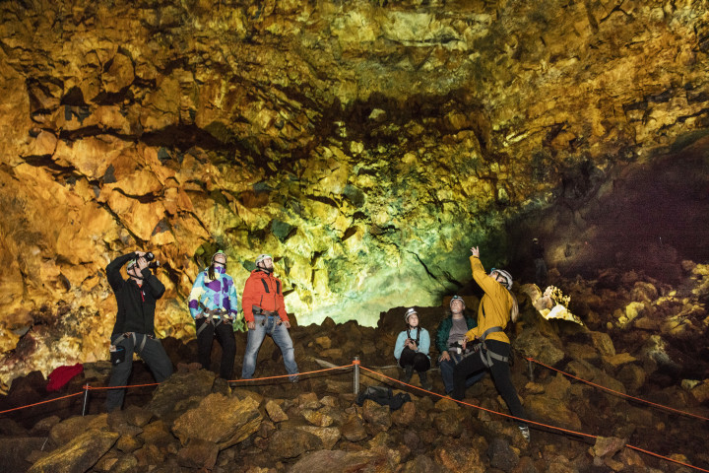
Next stop is Hótel Húsafell where you have an access to an outdoor swimming pool and free time before dinner and a good night’s rest!
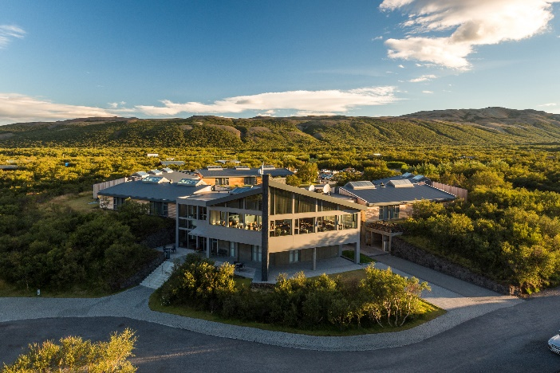
Tuesday August 7
Day 2 – Into the Glacier, Reykjavík
After breakfast the group will drive from Húsafell to Klaki base camp for the tour Into the Glacier. Your Into The Glacier Adventure is truly a unique experience. You will get the opportunity of a lifetime to enjoy one of the world’s greatest wilderness; Iceland’s second largest glacier – from the inside! Never before the Langjökull ice tunnels, has anyone been able to see the beautiful blue ice at the heart of an ice cap glacier. You’ll get to ride in a specially modified glacier vehicles on the glacier, explore the glacier environment, enjoy a view out of this world and go INTO the glacier to experience the glacier’s beauty from the inside! An experienced guide will lead the way the whole time to make sure everyone is enjoying themselves to the fullest.

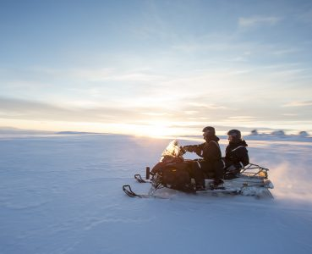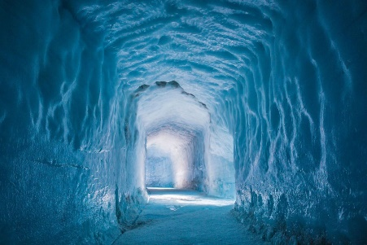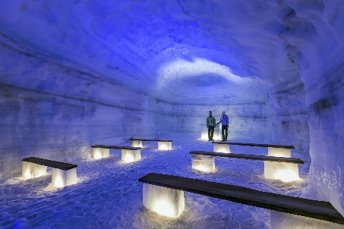
From Langjökull glacier we head back to the city, with estimated arrival in Reykjavík around 17:00.

Not Included: Lunches, refreshments & dinners August 6th and 7th.
Lunches and refreshments can be bought during scheduled breaks on both days, while dinner can be bought at Hótel Húsafell on August 6th. Post-excursion dinner on August 7th can be enjoyed at Reykjavík’s many excellent and internationally renowned restaurants!

